**Electrodynamics HW Problems**

**00 – Review**

1. Conducting shell
2. Conducting shell (off-center charge)
3. Field of a charged rod
4. Field of a charged ring
5. “Curly” E-field
6. Magnetic fields of household currents
7. Force between two moving line-charges
8. Magnetic resonance imager
9. Helmholtz coils
10. Force between charged hemispheres
11. General electric potential in cylindrical geometry
12. Potential inside/outside cylindrical shell
13. Potential in a dielectric cylinder
14. Electric dipole in a dielectric sphere
15. Magnetic field inside/outside wire
16. Vector potential of coaxial conductors
17. Dipole approximation of a current loop
18. Magnetic field from a magnetized sphere
19. Permeable sphere in a magnetic field

**0.01.** **Conducting shell** [Dubson SP12, Pollock FA11, Kinney SP11, Rogers SP09]

A positive point charge of *+Q* sits at the center of a hollow, neutral, spherical metal shell of inner radius *a* and outer radius *b*.

**(a)** Determine the electric field **E** in all space. You may use whatever method you think best, but be sure to explain your reasoning clearly.

**(b)** Describe how charge is distributed on the metallic shell. Be specific: where does the charge reside and how is it distributed? Explicitly calculate any charge densities that are non-zero, and discuss what kind of symmetry they have (if any).

**(c)** Find the voltage *V* everywhere in space, using the usual assumption that *V*(r→∞) = 0. Sketch the potential as a function of radius and comment briefly on any interesting features.

**0.02. Conducting shell (off-center)** [Pollock FA11, Kinney SP11, Rogers SP09]

A positive point charge of *+Q* sits inside, but NOT at the center of a hollow, neutral, spherical metal shell of inner radius *a* and outer radius *b*.

**(a)** Make a sketch of the charge and shell. What kind of symmetry, if any, does this charge-and-shell setup have? Describe how charge is distributed for the metallic shell. Be specific: where does the charge reside and how is it distributed? On your sketch, draw the electric field lines that you expect.

**(b)** Now think about how to determine the electric field **E** and voltage *V* in all space (using *V*(r→∞) = 0). From last semester you have a lot of “tools” at your disposal: Gauss’ law, direct Coulomb-style integration, the method of images, and sums of solutions of Laplace’s equation. For each region (*r < a, a < r < b,* and *r > b)* and for *each* of the tools mentioned above, discuss whether that “tool” could be used to find **E** and *V*, with the given information and any aspect of the solutions you know to be true from symmetry or properties of conductors.

**(c)** Go ahead and find the electric field **E** and voltage *V* everywhere in space using any method you prefer. *(This may be fairly challenging - take your time, review what you need to from last semester, work it out! Try to check your answer in as many ways as you can - units, signs, behavior near boundaries, etc!)*

**(d)** Using your answers to part (c), find any non-zero charge distributions on (or in) the shell. Do they agree with your expectations from part (a)? Briefly, comment/discuss.

**0.03.** **Field of a charged rod** [Dubson SP12]

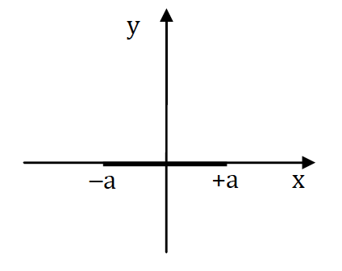

Consider a thin rod of length *2a*, negligible diameter, and uniform charge per length λ. The rod is centered on the origin, oriented as shown in the diagram.

**(a)** Compute the voltage at a position y on the y-axis. As usual, set the zero of voltage at infinity.

**(b)** From the voltage, compute the electric field at a position y on the y-axis. Simplify the result as much as possible.

**(c)** Write down expressions for the E-field in the limits y >> a and 0 < y << 1. (Note that the limit y >> a does not mean y = ∞. At y = ∞ the E-field is zero, and we want an expression for how **E** approaches zero, as y goes to infinity.)

**(d)** Argue that the limits you found in part (c) make sense, and that you could have figured out these limits directly without first computing the exact expression for **E**.

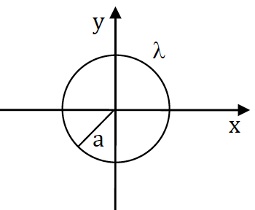

**0.04. Field of a charged ring** [Dubson SP12]

Consider a circular ring of charge in the *xy*-plane, centered on the origin, with radius *a*, and uniform charge per length λ.

**(a)** Derive an integral expression for the voltage *V(r)* outside the ring in the *xy*-plane, at a distance *r* from the origin, where *r* > *a*. Don't attempt to solve the integral – it's a messy one – just write it in a form that’s ready to plug into Mathematica.

**(b)** Now consider the voltage *Vq* due to a point charge at the origin having the same total charge at the ring in part (a). Derive an expression for the ratio of the voltage due to the ring and that due to the point charge: *V(r)*/*Vq(r)* for *r* > *a*. Use Mathematica to evaluate this ratio at *r* = 1.1*a*, *r* = 2*a*, and *r* = 10*a*.

**0.05. “Curly” E-field** [Dubson SP12, Pollock FA11]

Suppose an electric field in a region of space is given by

 (1)

where τ is a constant with units of time, and  is also a constant.

**(a)** What are the units of the constant ?

**(b)** Calculate the closed line integral

 (2)

where the path is a circle of radius R, parallel to the *xy*-plane, centered at (0, 0, z0). Integrate counter-clockwise as viewed from "above".

**(c)** Calculate the closed line integral equation (2) again, this time where the path is a rectangle (sides of length *a* and *b*) oriented parallel to the *xy*-plane. (Again, integrate counterclockwise as viewed from "above").

**(d)** Calculate  and describe the resulting vector field in words. Show that the closed line integral values in 3(b) and 3(c) are equal to the corresponding surface integrals of . Relate this to Stokes’ theorem!

**(e)** Determine the scalar potential that gives equation (1) (or explain why no such potential exists). Finally, describe how you could use such a static electric field to make a lot of money. Does the electric field in this problem violate any of Maxwell’s equation for a static situation?

*Does this "mathematical exercise" strike you as a physically unrealistic problem? We'll come back to this field soon, there's more to it than meets the eye!*

**0.06. Magnetic fields of household currents** [Dubson SP12]

**(a)** Use Ampere's law to compute the magnetic field around a long straight wire carrying a current *I*. Show your steps clearly.

The wires in the walls of your house carry currents as high as 15 A (if higher than 15 amps, the circuit breaker will trip, stopping the current). Estimate the magnitude of the magnetic field at a distance of 10 cm from a long straight wire carrying a current of 10 A. Compare this field to that of the earth's magnetic field.

**(b)** The wires in your house create negligible magnetic fields because the wires always come in pairs, carrying the same current in opposite directions. Consider two long, straight parallel wires, separated by a distance *d*, and carrying current *I* in opposite directions. Compute the magnetic field at a distance *r* from one of the wires, where *r* >> *d*. (We want the 1st-order term in the Taylor Series expansion for the answer, not the exact answer.) Use your answer to compute the size of the B-field at a distance *r* = 10 cm, if *d* = 2 mm, *I* = 10 A.

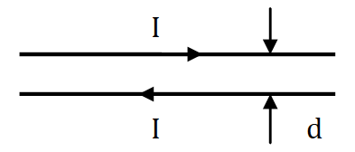

**0.07. Force between two moving line-charges** [Dubson SP12]

Consider two parallel infinitely long straight lines of charge, each with charge per length λ, and each moving with speed v as shown.

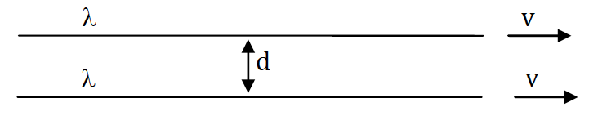

**(a)** What is the force per length on each wire due to their electrostatic repulsion?

**(b)** What is the force per length on each wire due to their magnetic attraction?

**(c)** How great would the speed v have to be in order to for the two forces to balance? Comment on how fast this is. (Speed of a snail? Speed of a jet plane?)

**0.08. Magnetic resonance imager** [Pollock FA11]

The magnetic field along the axis of a single circular loop of wire with radius *a*, carrying a current *I* is:



**(a)** *In this problem, consider a solenoid, which is effectively many such circular loops stacked up to make a cylinder*. Let's design a cylindrical solenoid for a magnetic resonance imager capable of imaging an adult human. Assume the solenoid has radius *a*, length *L*, is wrapped with *n* turns per unit length of wire, and the wire carries current *I*. Derive the functional form of the field, **B**(x) along the center line of the device, by integrating the contributions of a set of infinitesimally small loops.

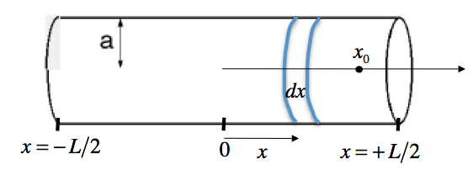

**I**

Explicitly show that your result approaches the "known" result () if the solenoid becomes infinite.

**(b)** Choosing appropriate (physically sensible) values for the length *L* and radius *a* (discuss your choices!), use a computer program to make a simple plot of the magnetic field vs. position (just along the central, x-axis).

Please make your horizontal axis the "dimensionless variable" *x*/*L*, and your vertical axis the "dimensionless magnetic field" .

**(c)** Show that your solution for the B-field satisfies Ampere's law (in integral form) around the following closed loop: along the central *x*-axis from –∞ to +∞, then perpendicular to the axis for an infinite distance, then parallel to the *x*–axis from +∞ to –∞ (but an infinite distance from the axis), and finally, close the loop at –∞. Give a convincing argument that the contributions from the paths at infinity vanish.

**(d)** Suppose the field near the center of an MRI is 3 T. Explain why it would be infeasible for an MRI electromagnet to use ordinary copper wire. *(This means making some reasonable estimates about wiring and geometry, looking up basic information you might need... We aren't asking for a detailed or particularly accurate calculation, but an order-of-magnitude estimate to show why this would not work in practice. Do you know what they do instead?)*

**0.09. Helmholtz coils** [Kinney SP11, Munsat FA10]

Often one needs to perform an experiment in a small region of space where you want either no magnetic field or only a small uniform magnetic field pointing in a particular direction. Since you can’t make a Faraday cage to shield the earth’s magnetic field (why not?), a straightforward solution is to create a uniform magnetic field that cancels the earth’s magnetic field (plus any stray fields from ferromagnetic materials nearby). It is possible to create a magnetic field that is extremely uniform by arranging two loops of equal current so that their centers are on the same axis (let’s say the *z*-axis) with a specific spacing between them (the axis is perpendicular to the plane of each loop). If you pick the right distance *d* between the coils, the first and second spatial derivatives with respect to *z* will go to zero at the center of the apparatus. Assuming you locate the coils symmetrically about *z* = 0, this can be written as  and .

**(a)** Sketch the arrangement of the two coils on the *z*-axis and choose an origin. Without performing any calculations, determine whether the currents in the loops should flow in the same or opposite directions around the loop, and choose the current directions in each coil accordingly.

**(b)** Given some distance *d* between the centers of the two coaxial current-carrying coils of radius *R* and current *I*, find the total magnetic field **B** on the z-axis. Show that , regardless of the value chosen for *d*.

**(c)** Find the value of *d* that results in . Show that in this case, the magnetic field on the *z*-axis halfway between the coils is given by .

**(d)** If you were asked to find the field off the *z*-axis, what method would you use to find **B**? Write down an integral expression for **B** at an arbitrary point in space; you do not need to solve the integrals but rather, they should be in a form ready to integrate. Be sure to define your coordinates system clearly.

**(e)** EVALUATION: What should the field look like very far away from the Helmholtz assembly (*r >> d, r >> R)?* What should the field look like very close to one of the coils (out on the loop, not at the center of the loop)? Remind yourself of what the magnetic field from a single loop looks like (*e.g.,* Griffiths p. 246). What kind of symmetry do you expect for the field from the Helmholtz assembly? Without performing any calculations, what can you say about any non-*z*-components of the field close (but not on) the *z*-axis? Are they large or small? Explain your reasoning. Finally, using your conclusions from thinking (not calculating), make a sketch of the field lines that you expect in the space around and in between the coils (even though you only have found the field on the *z*-axis).

**0.10. Force between charged hemispheres** [Munsat FA10]

Consider a uniformly charged sphere with radius *R* and total charge *Q*. Show that the top half exerts a net force on the bottom half given by .

Hint: What is the net force that the top half exerts on the top half?

**0.11. General electric potential in cylindrical geometry** [Munsat FA10]

Show (by solving Laplace’s equation in cylindrical coordinates using separation of variables) that the most general form of the solution for the potential is:



**0.12. Potential inside/outside cylindrical shell** [Munsat FA10]

Consider a long cylindrical shell of radius *R* that has a uniform surface charge density  on the top half (i.e. ) and  on the bottom half (i.e. ). Use the solution from problem [11] with the appropriate boundary conditions to find the potential everywhere inside and outside the cylinder.

**0.13. Potential in a dielectric cylinder** [Munsat FA10]

Consider a long cylinder of radius *R*, made of linear dielectric material with susceptibility , placed in a uniform electric field . The axis of the dielectric cylinder is perpendicular to . Use the solution from problem [11] with the appropriate boundary conditions to find the potential everywhere inside the cylinder.

**0.14. Electric dipole in a dielectric sphere** [Munsat FA10]

Consider a point dipole  placed at the center of a sphere of radius *R*, made of linear dielectric material with dielectric constant . Show that the potential inside and outside the sphere is given by:

 ( r < R )  ( r > R )

Be careful with , , and !

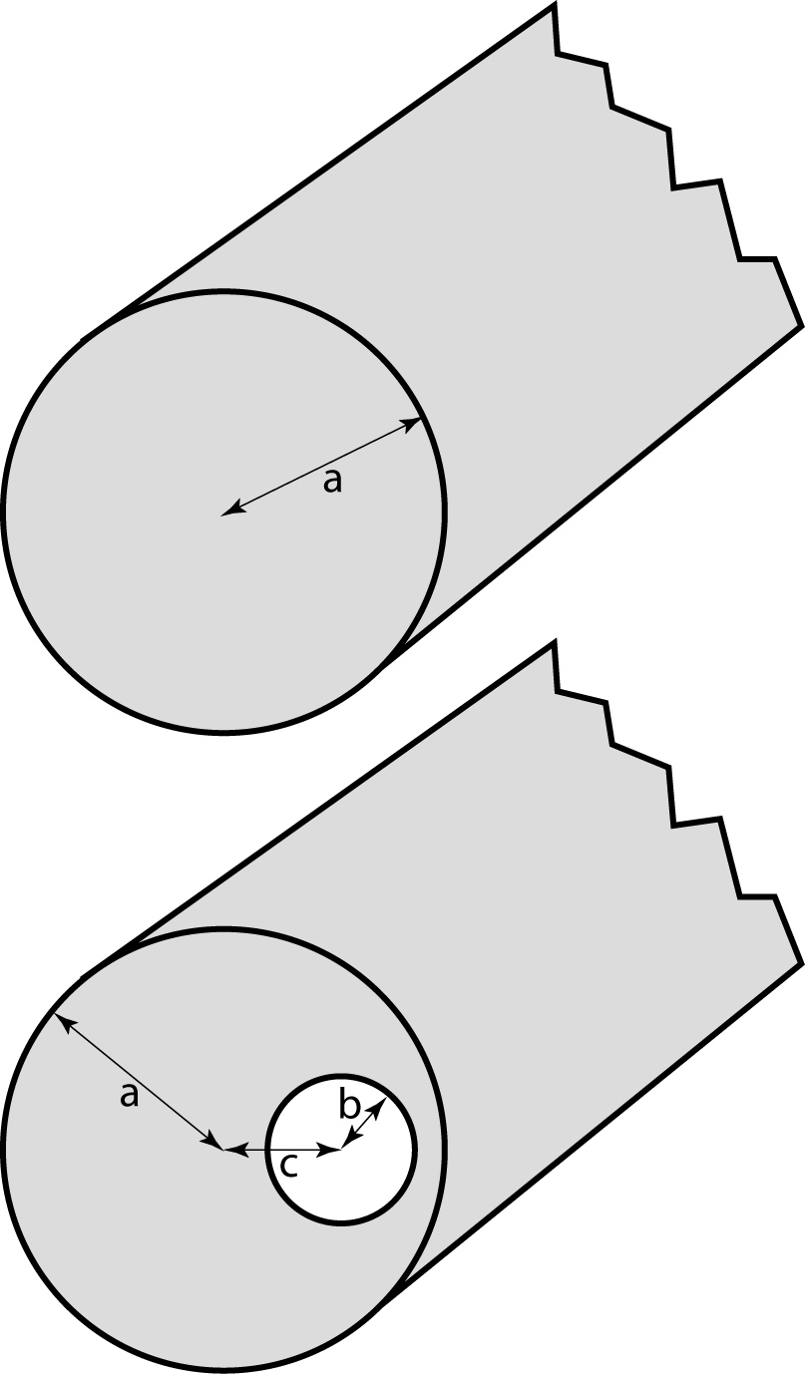**0.15. Magnetic field inside/outside wire** [Munsat FA10]

Consider a long cylindrical wire with radius *a*, carrying a total current *I*.

**(a)** Find the magnetic field everywhere inside and outside the wire, assuming the current is uniformly distributed over the *outer surface* of the wire.

**(b)** Find the magnetic field everywhere inside and outside the wire, assuming the current is uniformly distributed through the *volume* of the wire.

**(c)** Now we take an infinitely long drill bit and drill a cylindrical hole through the length of the wire, but keep the total current the same. The hole has a radius *b* and is located a distance *c* from the center of the wire (offset in the *x*-direction). Find the magnetic field inside the hole, assuming the current is uniformly distributed through the *volume* of the wire material.

**0.16. Vector potential of coaxial conductors** [Munsat FA10]

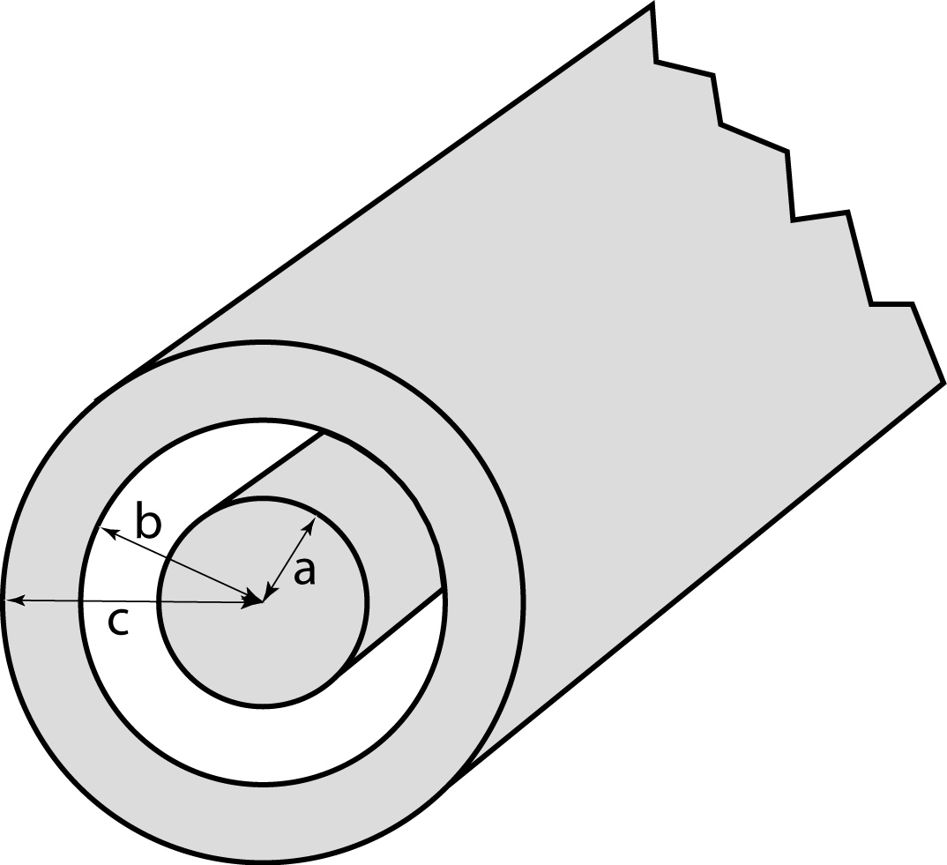Consider a pair of infinitely long coaxial metal cylinders, with dimensions as shown. The inner cylinder carries a current *I* in the -direction, and the outer cylinder carries a current *I* in the -direction. The current is uniformly distributed through the volume of the material.

Find the vector potential  everywhere. Express your answer in terms of , the value on the axis.

Is it possible to make  outside the cylinder? If so, what would this condition force  to be?

**0.17. Dipole approximation of a current loop** [Munsat FA10]

Consider a loop of wire with radius *R*, carrying a current *I*, centered at the origin, oriented in the *xy*-plane.

**(a)** What is the magnetic dipole moment?

**(b)** What is the approximate B-field on the z-axis, in the dipole approximation? Under what conditions is this approximation valid?

**(c)** Using a computer plotting routine (MathCAD, Mathematica, Excel, etc.), compare the field above the center of the loop in the dipole approximation to the exact solution (given in Griffiths eq. 5.38). Namely, on the same plot show both solutions for *B*(*z*), plotted from 0 to some appropriate . Label the *z*-axis in terms of *R* (i.e. label 0, *R*, 2*R*, etc.). Make it a semi-log plot so we can tell what’s going on.

**0.18. Magnetic field from a magnetized sphere** [Munsat FA10]

Consider a sphere of radius *R*, magnetized so that the magnetization is spherically symmetric, radially directed (i.e. ) and is finite at the center.

**(a)** Find the bound current densities  and .

**(b)** If there are no free currents anywhere, find  inside the sphere.

**(c)** Find  inside the sphere.

**(d)** Find  immediately outside the surface of the sphere.

**0.19. Permeable sphere in a magnetic field** [Munsat FA10]

A sphere of radius *R* and permeability μ is placed in a previously uniform magnetic field . Find  everywhere.